9

***Dataflow of Our Project:***

***Smart Home***

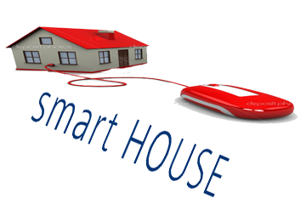

***Team members:***

*1-khaled Abd El Nasser " leader".*

*2- Islam Mohamed Mahmud.*

*3-Eatemad Mohamed Mahmoud*

*4-Khaled Hassan abd elhalem*

*5-abd allah Mohamed*

*6-mostafa ali*

***Dataflow***

