***Use case:***

***Smart Home***

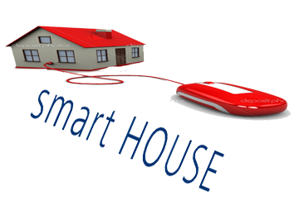

***Team members:***

*1-khaled Abd El Nasser " leader".*

*2- Islam Mohamed Mahmud.*

*3-Eatemad Mohamed Mahmoud*

*4-Khaled Hassan abd elhalem*

*5-abd allah Mohamed.*

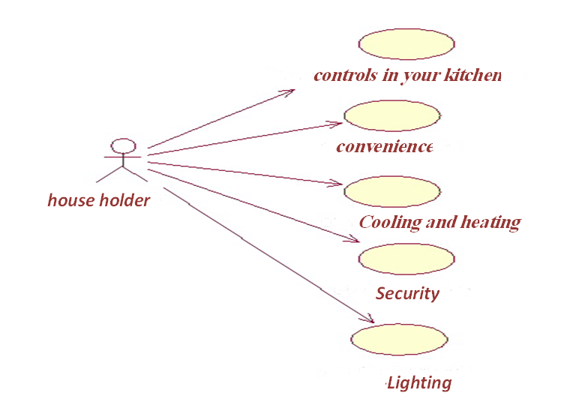

***Use case***

The actor is a house holder.

The house holder initiates the scenario by

* Login the application.
* Then makes aselection .
* Control in your house.
* Log out from the application.

***Preconditions*** no have a time to mack all thing in the house , not have a control in house.

***Postconditions*** helping family members live in total comfort while at home or away.